Q)Do we have to show the primary key of relationship set or only the additional attributes have to be shown?

Q) what does dotted line joining relationship to attribute means in the following diagram?

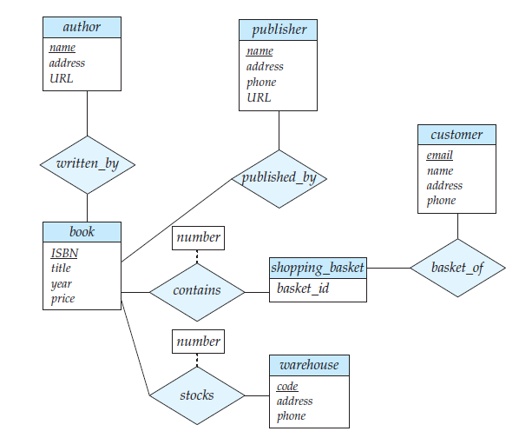

If a relationship set has some attributes associated with it, then we enclose the attributes in a rectangle and link the rectangle with a dashed line to the diamond representing that relationship set.(fig 7.8)

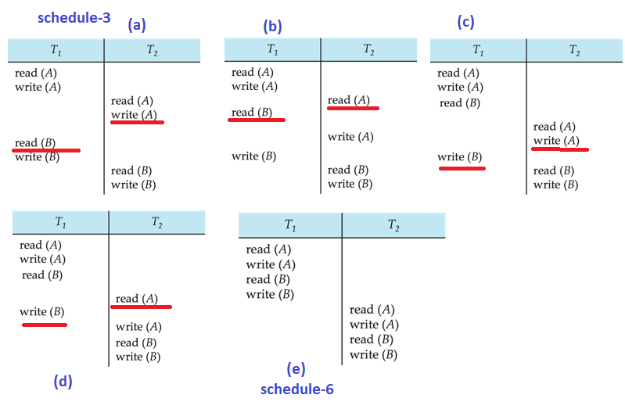

Q) in a schedule does a single swap of consecutive non conflicting instructions give a conflict equivalent schedule (like fig a and b) or do we have to swap all occurring consecutive non conflicting instructions?

Single swap is not sufficient as there are read write issues still unresolved. This example is also explain in slide 40 of transaction chapter.

Upto fig(e) swaps are needed to get conflicit equivalent schedule

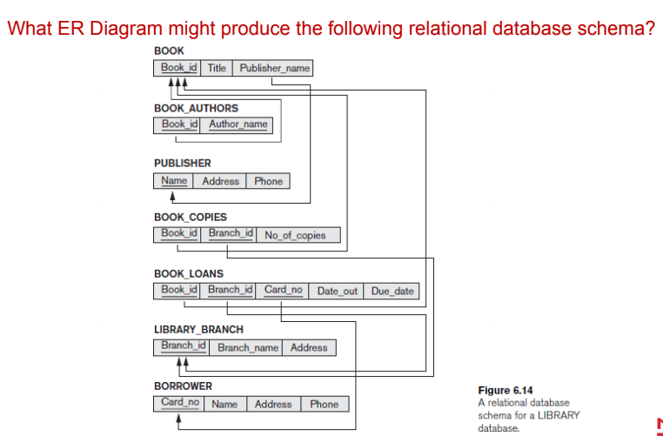

Maam Please verify my answer

